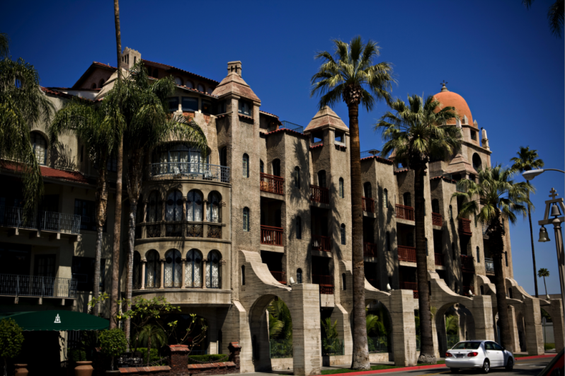
The Mission Inn Hotel and Spa, a hotel in Riverside, California, is a piece of architecture almost as old as the city itself. For years, its stone walls and tiles roof have stood in the same place as a window to the past, even as modern office buildings, suburbs, and freeways gradually sprouted around it and the city’s expansive orange groves began to disappear. Despite its age, some may say that the Mission Inn is not a good representation of Riverside’s history and culture because it has been renovated and expanded so many times since it was first constructed in 1876. Rather than being a pure symbol of the city’s essence, one may note that it has absorbed the influences and styles of other times and other regions. They may also doubt the extent to which the Mission Inn serves the local people as compared to wealthy out-of-state guests. It is true that the Mission Inn in its current state is very different than the humble boarding house that it once was. However, in spite of these changes, the hotel still retains many aspects of its original California mission-inspired style, and continues to serve the people of Riverside even while welcoming guests from outside of the city. Thus, the Mission Inn remains, at its core, a good representation of Riverside’s culture.
Street view of the Mission Inn. Photo credit: www.myownrealtypro.com
Any article that accurately reflects local culture is called “critical regionalism.”
Writer Keith Eggener discusses critical regionalism, as well as its value and legitimacy as a term in his work “Placing Resistance: A Critique of Critical Regionalism.” In this work, he mentions another writer, Kenneth Frampton, who says that one of the main purposes of critical regionalism is “’to reflect and serve the limited constituencies’ in which it was grounded” (Eggener 228). However, Eggener worries some of the things that we associate with a particular culture are not actually a reflection of that culture at all, but rather a stereotypical image of it imposed by outside forces. This image serves them and not the people that it is supposed to represent. Frampton also proposed the idea of critical regionalism as an “architecture of resistance,” or as a way of resisting a more homogenous, modern culture. Frampton accepts that architecture will most likely contain some modern elements, but as Eggener clarifies, “To be regional and modern involve[s] an extremely delicate balance” (Eggener 229). At first, it may seem as though the Mission Inn does not meet either of Frampton’s standards, confirming Eggener’s misgivings.
First, it could be argued that the Mission Inn has an excessive amount of influence from outside of the city whose culture it represents. The hotel’s founder, Cristopher Miller, and his son Frank Miller, who was responsible for the hotel’s conversion from a boarding house to a resort, came to California from Wisconsin. Thus, they may not have had as strong of a grasp of Californian, or Riverside culture as a Riverside local would. Additionally, Frank Miller liked to travel to different parts of the United States as well as different countries in Europe and Asia, and would bring back souvenirs, such as the “Nanking temple bell” from China, that he would display in the hotel. Some parts of the hotel itself are inspired by these travels.
In addition to being physically influenced by other regions, one could point to the hotel’s change in clientele over the years as evidence that it is not a good example of critical regionalism. When the hotel, originally a small boarding house known as the “Glenwood Hotel,” first opened in 1876, it mainly served local agricultural workers, most likely working for the region’s lucrative citrus industry. According Steve Lech and Kim Jarell Johnson in their book, Riverside’s Mission Inn, however, the Inn changed from a boarding housing for local workers to “a grand destination hotel, the type that would attract and retain visitors from the cold east and Midwest who would stay for month at a time.” (Johnson 7) In other words, the hotel very quickly adapted to serve wealthy outsiders instead of average local citizen. “The Mission Inn,” Lech and Johnson explain, “grew out of the need to house successive waves of very wealthy tourists coming to Riverside” (Johnson 7). This is the type of guest that tends to visit the Mission Inn to this day, as both room reservations and the restaurants that operate within the hotel are very pricey, with a single-night stay for one adult ranging from $179 to $749 per night. Thus, by appearing not to serve the local people, the Mission Inn seems not to be a true example of critical regionalism.
Furthermore, it is worth mentioning the hotel’s multiple renovations, and the hotel’s modern amenities. Originally a smaller building with just 12 rooms Lech (Johnson 7), the Mission Inn now has “238 guest rooms and 27 upscale suites...complete with luxurious and modern amenities” (Historic Hotels of America). These amenities include a fitness center, a spa, and a heated outdoor pool. Over the years, the hotel was updated multiple times to reflect contemporary aesthetics. For example, in 1956, the hotel’s owner, Benjamin Swig tried to update the hotel to reflect “the latest midcentury styles” (Mission Inn Foundation).
However, despite the Mission Inn’s renovations and outside influence, it is still a good example of critical regionalism that keeps Riverside’s culture and history at its heart.
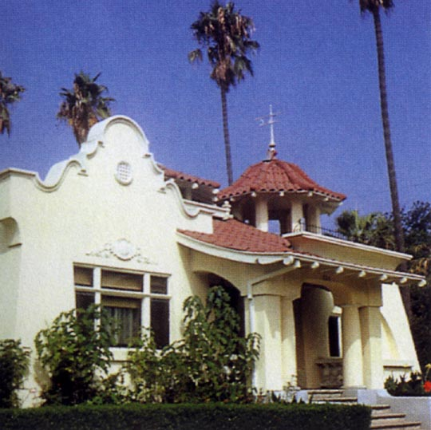
Although the Miller family came from outside of California, they based the Mission Inn’s architecture on authentic California Missions (all 21 according to the hotel’s website), and the Mission Revival architecture that was unique to California at the time. In fact, Mission Revival architecture itself can be considered an “architecture of resistance” as Frampton calls it. Mission revival architecture became popular in California in the early 1900s, roughly fifty years after California was ceded to the United States by Mexico in 1848. Following California’s addition to the American territories, Californian architecture began to reflect styles from the East coast and other parts of the United States. In response to this, Californians began to embrace their own local culture, which included Mission architecture, incorporating into homes and other buildings. (Essley) This style of architecture Original Mission architecture from the 1700s evolved over time, but was mainly characterized by Spanish and European styles expressed through the medium of local materials. (Newcomb 226). Some of the mission features that can be seen in mission architecture that can also be found in Mission Revival architecture and the Mission Inn are the use of stucco, stone, tile roofs, balconies, domes, and a central courtyard. Another style present in the architecture of the Mission Inn is the “Arts and Crafts” style, which was popular at the same time as Mission Revival. The “Arts and Crafts” style was part of a movement in The United States and England to embrace a simple, hand-made aesthetic in response to the industrialization that was taking place at the time. (Gray). This movement fit in well with mission-revival architecture, as the missions upon which this architecture was based were often made with local materials by priests, monks, and other common people with no prior experience in architecture. “The Historic Hotels of America” website also mentions the use of “design features from throughout the Southwestern United States, Mexico, and several Mediterranean countries” by the Mission Inn. This, to some extent supports the authenticity of the hotel’s architecture, as the California Missions themselves drew inspiration not only from Spain, but also Mexico, the Southwest, and Europe (but not necessarily the Mediterranean) (Newcomb 225).
Example of Mission Revival architecture. photo credit: www.geog.ucsb.edu
The Mission Inn hotel, although it comes quite close, doesn’t entirely share its cultural origins with the California missions, and has been influenced partly by the international escapades of Frank Miller. In spite of this, Douglass Powell, another author who discusses critical regionalism, might argue that the Mission Inn is still an example of critical regionalism. In his work “Critical Regionalism: Connecting Politics and Culture in the American Landscape,” Powell mentions that we can’t just look at a region in an isolated way; we need to look at its interactions with other regions and the global community as a whole as well. The global collections kept at the hotel may not be a part of Californian culture, but they are what set the Mission Inn aside as something that is uniquely “Riverside.” Rather than being a reflection of just any Californian Mission, it has become a building with its own unique history and personality.
Additionally, although the Mission Inn’s pricey rooms may not be aimed at the common Riverside citizen, the hotel does still serve the community. Regardless of whether or not one is a guest, he or she is welcome to walk through the hotel's halls and courtyards to read about its rich history and enjoy its unique architecture. The Mission Inn, as part of the entire city block that it occupies, contains a museum that is free and open to the public and The Mission Inn Foundation and Museum, a group founded to preserve the Mission Inn and its history in 1976, offers daily walking tours. The museum also contains archives that are available for use (by appointment) for anyone who is interested in using them for research.
Each year in December, one can also take part in a relatively new tradition called The Riverside Festival of Lights. Started in the 1990s by the Mission Inn’s current owner, Riverside area native Duane Roberts, the free event extends throughout the entire downtown area with the hotel at its core. The owners of the hotel begin decorating the Mission Inn and surrounding buildings with lights, animatronic carolers, towering nutcracker figures, and other Christmas regalia months in advance in preparation for the month-long celebration that boasts thousands of attendees from both inside and outside of the Riverside area. The celebration involves the entire city. Its co-sponsors include the Greater Riverside Chamber of Commerce and Riverside Public Utilities, and volunteers from the community participate to keep the event clean, safe, and fun.
In addition to the Festival of Lights, the Mission Inn joins the rest of the downtown area in hosting “First Sundays,” an event in which local businesses and organization host crafts and games to encourage children’s’ engagement in the arts. Sometimes, school district events such as “Good Morning Riverside” (An annual meeting of school district officials, teachers, students, and staff to discuss district news, new studies regarding education, share experiences, etc.) and the annual district-wide coloring contest are also held at the hotel. Therefore, although the Mission Inn’s rooms are targeted at the wealthy, the hotel fits Frampton’s definition of critical regionalism by serving the local people.

By serving the local people and acting as an “architecture of resistance” as Frampton suggests, while avoiding the outsider-imposed stereotypes that Eggener fears and embracing the outside influences that Powell accepts in its own unique way, the Mission Inn Hotel and Spa can be considered a good example of critical regionalism. It is true that over the many years that the structure now called the Mission Inn Hotel & Spa has been serving guests, it has undergone multiple changes, turning the once- modest boarding house into an expansive luxury resort and picking up the styles of various cultures and time periods along the way. Some would argue that all of this change detracts from the hotel’s local feel. However, due to its unique style, historical roots, and ongoing connection with the community it remains a good example of critical regionalism. It has evolved along with the city it was built in, and it embraces modern improvements while honoring its past.

Works Cited

“The 23rd Annual Festival of Lights.” The 23rd Annual Festival of Lights. 2015. City of Riverside. Web. 28 Jan 2016. http://www.riversideca.gov/fol/default.asp

“Annual Riverside Festival of Lights.” Riverside. Riverside Convention and Visitors Bureau. n.d. Web. 22 Jan 2016 <http://www.riversidecvb.com/event/annual-riverside-festival-lights>

Essley, Joffrey. “Mission Revival Architecture.” House Design Coffee. n.p. n.d. Web. 22 Jan. 2016 <http://www.house-design-coffee.com/mission-revival-architecture.html>

Gray, Liz. “Arts and Crafts Architecture.” HGTV. Scripps Networks, LLC. n.d. Web. 28 Jan 2016 <http://www.hgtv.com/design/home-styles/arts-and-crafts-architecture>

Harvey, Steve. “Riverside Mission Inn big on tradition and history.” Los Angeles Times. Los Angeles Times. 29 Nov 2009. Web. 22 Jan 2016. <http://articles.latimes.com/2009/nov/29/local/la-me-then29-2009nov29>

“Historic Riverside Walking Tour—Mission Inn Avenue.” Inland Empire.com. InlandEmpire.com. n.d. Web. 22 Jan 2016
<http://www.inlandempire.com/historic-riverside-walking-tour-mission-inn-avenue/>

“History of Riverside.” City of Riverside. City of Riverside. n.d. Web. 22 Jan 2016. <http://riversideca.gov/visiting-aboutriv.asp>

Johnson, Kim Jarell; Lech, Steve. Riverside’s Mission Inn. United States: 2006. Web.

Mission Inn Foundation. Institute of Museum and Library Services, n.d. Web. 22 Jan 2016. <http://missioninnmuseum.org/>

“The Mission Inn Hotel & Spa.” Historic Hotels of America. Historic Hotels of America.n.d. Web. 22 Jan 2016 <http://www.historichotels.org/hotels-resorts/the-mission-inn-hotel- and-spa/history.php>

The Mission Inn Hotel & Spa. The Mission Inn Hotel &Spa, n.d. Web. 22 Jan. 2016 <http://www.missioninn.com/>
Newcomb, Rexford. “Architecture of the California Missions.” Annual Publication of the Historical Society of Southern California. Vol. 9, No. 3 1914: p.225-235. Web. <http://www.jstor.org/stable/41168709?seq=6#page_scan_tab_contents>

Sahagun, Louis. “Historic Mission Inn Prepares to Open After $40-Million, 3 ½ Year Renovation.” Los Angeles Times. Los Angeles Times. 26 Nov 1988. Web. 22 Jan 2016. <http://articles.latimes.com/1988-11-26/news/mn-132_1_mission-inn>

“Treaty of Guadalupe Hidalgo.” History. A&E Television Networks. n.d. Web. 28 Jan 2016 <http://www.history.com/topics/treaty-of-guadalupe-hidalgo>
Warren, Jennifer. “Heart of Riverside ‘Held Hostage’ with Delay in Mission Inn Reopening: Landmark: The historic hotel was repossessed during a five-year renovation and the bank is seeking a buyer.” Los Angeles Times. Los Angeles Times 10 Dec 1990. Web. 22 Jan 2016.
<http://articles.latimes.com/1990-12-10/news/mn-4678_1_mission-inn>

Post-mortem:
The writing concept that I found to be the most useful was essay structure/ organization. Often, I have a lot of ideas regarding projects, as well as information, but it is difficult for me to arrange this information in a logical and organized manner. Therefore, it was helpful for me to review this in class, as well as to discuss organization during the conference. I also appreciated the information about motive and constructing good introduction paragraphs. For this project in particular, in which there were multiple things that I had to address (the issue of whether or not my cultural document was an example of critical regionalism, describing the document, explaining what critical regionalism was and using various lenses with regard to critical regionalism), so it was helpful to find an organized way of making all of this interesting to my audience and easier to follow, even if I cannot do this perfectly yet. In terms of writing process elements, I found the feedback at each step (including the peer review and the conference) helpful for narrowing my focus, and knowing when I needed to clarify or better support my claims. I think that it was good to get an outside perspective on my work to get a better idea of how my audience might interpret it, and how I could make it clearer and more interesting for them.

