A proposition: Dickinson anticipated the digital age with her word and poem variants.

A question: When is a poem FINISHED? Who decides? What is the role of the editor?

Read the following poem, F1263, written around 1872 by Emily Dickinson, as it appears
in Poems edited by R. W. Franklin (1998). Then, look at the manuscript version.

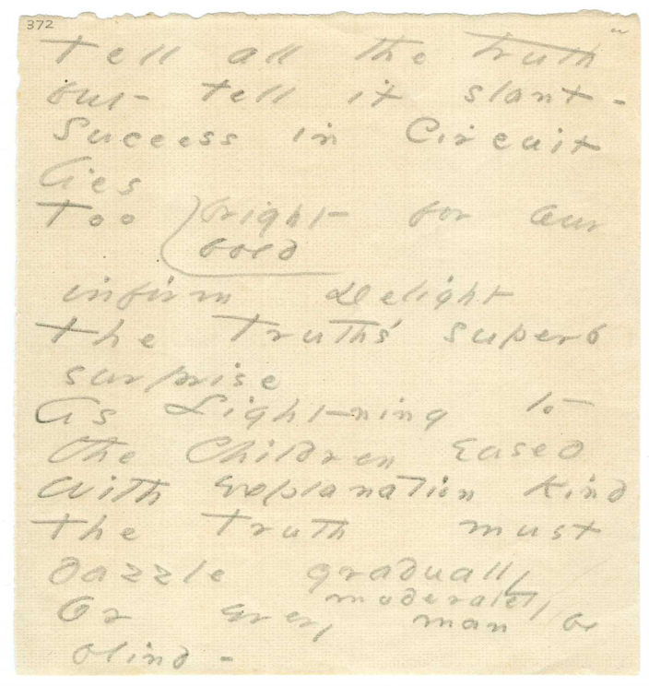
Tell all the truth but tell it slant -
Success in Circuit lies
Too bright for our infirm Delight
The Truth's superb surprise

As Lightning to the Children eased
With explanation kind
The Truth must dazzle gradually
Or every man be blind -

What differences do you notice between the printed version of the poem and the manuscript?

Look at the word “bright” in the third line and its variant of “bold,” and “gradually” in the 7th line with the variant “moderately.” How do these variants change your reading of the poem?

Why do you think Dickinson put the variants right in the poem and not at the end?

A few key terms:
Manuscript = ________________________________________________________________

Fair Copy = _________________________________________________________________

Fascicle = ___________________________________________________________________

Variant = ___________________________________________________________________

Editor = ____________________________________________________________________

“Authoritative edition” = _______________________________________________________

Now look at two different edited versions of “They dropped like Flakes.”
THE BATTLE-FIELD (P 91-133)
They dropped like flakes, they dropped like stars,
Like petals from a rose,
When suddenly across the June
A wind with fingers goes.
They perished in the seamless grass,
No eye could find the place;
But God on his repealless list
Can summon every face.
Franklin F545
They dropped like Flakes –
They dropped like stars -
Like Petals from a Rose -
When suddenly across the June
A Wind with fingers – goes -
They perished in the seamless Grass -
No eye could find the place -
But God can summon every face
On his Repealless - List.

What differences do you notice between the two versions of this poem?
What is the role of an editor? Which version do you prefer? Why?

Dickinson’s Publication History (Major Editions):

1. Poems, 1st, 2nd and 3rd editions. Edited by Thomas Higginson and Mabel Loomis Todd: 1890, 1891, 1896. (=P)
2. The Complete Poems of Emily Dickinson, edited by Thomas Johnson, 1955. (=J)
3. The Poems of Emily Dickinson: Variorum Edition, edited by R. W. Franklin, 1998. (=F)
4. C. Miller, editor, Emily Dickinson’s Poems as she Preserved Them, 2016. organized by fascicles with variants on page. (=C+ page number)
*Important: The Manuscript Books of Emily Dickinson. Edited by R. W. Franklin. 2 vols., 1981.

**Most important: EDA: Emily Dickinson Archive: An Open Access Website for the Manuscripts of Emily Dickinson. This digitizes all of Dickinson’s manuscript poems and allows you to search for P, J and F versions AND to see what Dickinson’s herself “published” in her fascicles.

Digital Sites for self-editing the poems:

- EDA: Emily Dickinson Archive: An Open Access Website for the Manuscripts of Emily Dickinson. Houghton Library, Harvard University; contains the manuscripts of all the poems in Franklin’s edition. https://www.edickinson.org

- Emily Dickinson Lexicon, edited by Cynthia Hallen, lists and defines over 9,000 words Dickinson used and where she used them, and gives the definitions from the dictionary she owned, loved and consulted: Webster’s 1844 American Dictionary of the English Language https://edl.byu.edu/

- White Heat: Emily Dickinson in 1862, a weekly blog. Each week for the year 1862 focuses on a different theme relevant to Dickinson and looks at the history of that week and theme, the biographical connections and offers a group of poems on the weekly theme with comments about reading them. https://journeys.dartmouth.edu/whiteheat/

