Data Befriends Philanthropy

The Potential for Mutually Beneficial Relationships Between Global Health Practitioners and Health Metrics Organizations



Figure 1. IHME Logo. Source: <http://adolescentsourfuture.com/wp-content/uploads/IHME-logo.png>

Uma Ramesh

WRIT044.02

Rachel Obbard

**Executive Summary**

Today, the global health community can claim tremendous accomplishments, from increased recognition of the field to nations’ impressive progress towards the Millennium Development Goals. Yet health crises continue to wreak havoc on the world’s most vulnerable populations. Unfortunately, global health practitioners might soon find themselves with reduced funding to address these crises, given the diminished role of health in the Sustainable Development Goals. In the face of these challenges, health metrics can help philanthropic groups adapt. For practitioners addressing multiple global health issues at once, comprehensive data adds clarity, enabling leaders to identify the populations most in need. For philanthropic groups seeking to partner with powerful stakeholders, health data enhances the visibility of their work; the largest donors in global health increasingly value metrics-based evaluation.

The Institute of Health Metrics and Evaluation (IHME) is the only organization that provides detailed health metrics grounded in impartiality. As such, the IHME hopes that global health practitioners will join its collaborator network – a broad, diverse group of stakeholders who provide timely feedback on the organization’s research. Philanthropic groups possess an intimate and incomparable understanding of the cultural contexts in which they work. By leveraging their own expertise to interpret IHME data, practitioners increase the organization’s understanding of social, cultural, and political forces motivating data trends. Therefore, collaborators significantly heighten the policy relevance of IHME research for all.

**Global Health Today: Achievements & Challenges**

Global health practitioners can claim an outstanding number of accomplishments. Three to four decades ago, the field was relatively unknown [8]. This past April, over 1700 of the world’s leading academics gathered for the 8th Annual Conference of the Consortium of Universities for Global Health [9]. Further, most states achieved accelerated rates of progress towards health targets during the Millennium Development Goals era, excelling in the areas of child mortality, maternal mortality, HIV/AIDS, and tuberculosis [10]. In total, over 21 million more lives were saved than would have been if all states had simply maintained pre-MDG rates of progress [10].



Figure 2. Visual representation of Millennium Development Goals. Source: <http://smiletothefuture.org/wp-content/uploads/2015/11/millenium-development-goals.gif>

Despite these vital advancements, the path ahead for global health is rife with challenges. A 2015 United Nations task force, assessing the Millennium Development Goals, noted that most developing countries still face serious obstacles as they strive to improve their citizens’ health [17]. In particular, progress has remained stalled for least developed countries (LDCs) and small island developing States (SIDS) [17]. Further, funding sources for global health practitioners might soon become far more competitive, if donors shift their priorities during implementation of the Sustainable Development Goals [12]. While global health occupied a central position in the MDGs – with three of its eight targets directly focused on health –

the SDGs’ focus is quite different. As a comparison between Figures 2 and 3 illustrates, the Sustainable Development Goals only contain one explicitly health-focused target [11, 16].



Figure 3. Visual representation of Sustainable Development Goals. Source: http://one-[org.s3.amazonaws.com/us/wp- content/uploads/2015/07/rsz_775x775-global-goals-600x600.jpg](org.s3.amazonaws.com/us/wp-content/uploads/2015/07/rsz_775x775-global-goals-600x600.jpg)

**Data Adds Value**

In this tumultuous landscape, many global health practitioners seek strategies to secure steady sources of funding and enhance their impact. These goals could form the basis for a robust partnership between global health practitioners and health metrics organizations. Comprehensive, impartial data empowers global health practitioners to demonstrate the urgency of their work. Health metrics also allows philanthropic organizations to more clearly examine their impact, catalyzing vital reflection that could save countless lives.

Just 15 years ago, health metrics was a fledgling field without significant interest from global health stakeholders [13]. However, at present, leveraging data can be a highly effective tool for sustaining interest from funders. Most of the largest donors within global health are beginning to take a keener interest in metrics-based evaluation. For example, the Bill and Melinda Gates Foundation is striving to enhance the geospatial data available for African countries, as well as the quality of educational data within the American public school system [12, 2, 4]. The United States government – the largest donor in global health – has also significantly increased its focus on data, with federal agencies legally mandated to produce annual reports justifying the impact of their spending [15, 18, 19].

Further, evidence indicates that justifying one’s work through data endows it with more legitimacy for policymakers, significantly accelerating social change. For example, Julio Frenk, Mexico’s minister of health from 2000 to 2006, performed a national ‘burden of disease’ assessment during his tenure; the results identified certain conditions, including breast cancer, arthritis, and mental illness, as having a far greater impact on the population than was expected [14]. Frenk used this data to argue for a new national insurance plan that covered medication for breast cancer and arthritis, as well as treatment for mental illness [14]. Frenk’s reforms were successful; he credits his reliance on health metrics [14].

**Impartial, Comprehensive Health Metrics: the IHME’s unique role**

On the whole, global health practitioners would obtain key benefits from effectively leveraging data in their work. Specifically, philanthropic organizations would gain the most from comprehensive, impartial data sources. At present, the Institute for Health Metrics and Evaluation (IHME) occupies a unique niche in global health, as the only organization that provides such information. The IHME is a research center based at the University of Washington. The organization seeks to quantify the health impact of every disease that causes death or disability across the world, and has nearly reached its goal. Its annual report, the Global Burden of Disease (GBD), synthesizes data from over 2,300 researchers in more than 130 countries; its data-gathering process is outlined in Figure 4 [1]. The GBD provides empirically-based prevalence estimates for over 300 diseases and injuries in 195 nations, by age and sex, from 1990 to the present [1].



Figure 4. Visual representation of IHME’s data-gathering process.

The GBD’s broad scope makes it a valuable tool for global health practitioners across the world. This research also allows philanthropic groups to view diseases’ impact from multiple

perspectives, providing leaders with maximal clarity on the challenges they face. The Global

Burden of Disease uses three distinct metrics to assess a health condition’s effect on a population [6]. The first is death; global health practitioners can examine both death rates and the number of people killed by a specific disease [6]. The GBD also analyzes disease by measuring YLDs - short for ‘years lived with disability’ [6]. This metric describes the number of years that individuals with a condition spend in less than ideal health [6]. For example, the YLD for epilepsy, which can last a lifetime, would be greater than that for influenza, which often lasts only a few days [6]. The GBD’s third key measure is the DALY, or ‘disability-adjusted life year’; one DALY represents a year of healthy life lost [6]. In other words, this metric is a sum of YLDs and years of life lost due to premature mortality [6].

The GBD’s multiple metrics allows global health practitioners to alter their use of health data as circumstances demand. For philanthropic groups designing a public awareness campaign, it might be most effective to emphasize the number of lives lost to a disease. In contrast, policy-makers focused on workplace productivity might be more interested in a condition’s YLD. Figure 5 presents two visualizations of health challenges faced by women of reproductive age in Sub-Saharan Africa. The first is based on DALYs, the second on YLDs; the significant differences between each image reflect the holistic knowledge philanthropic groups can gain from IHME data.

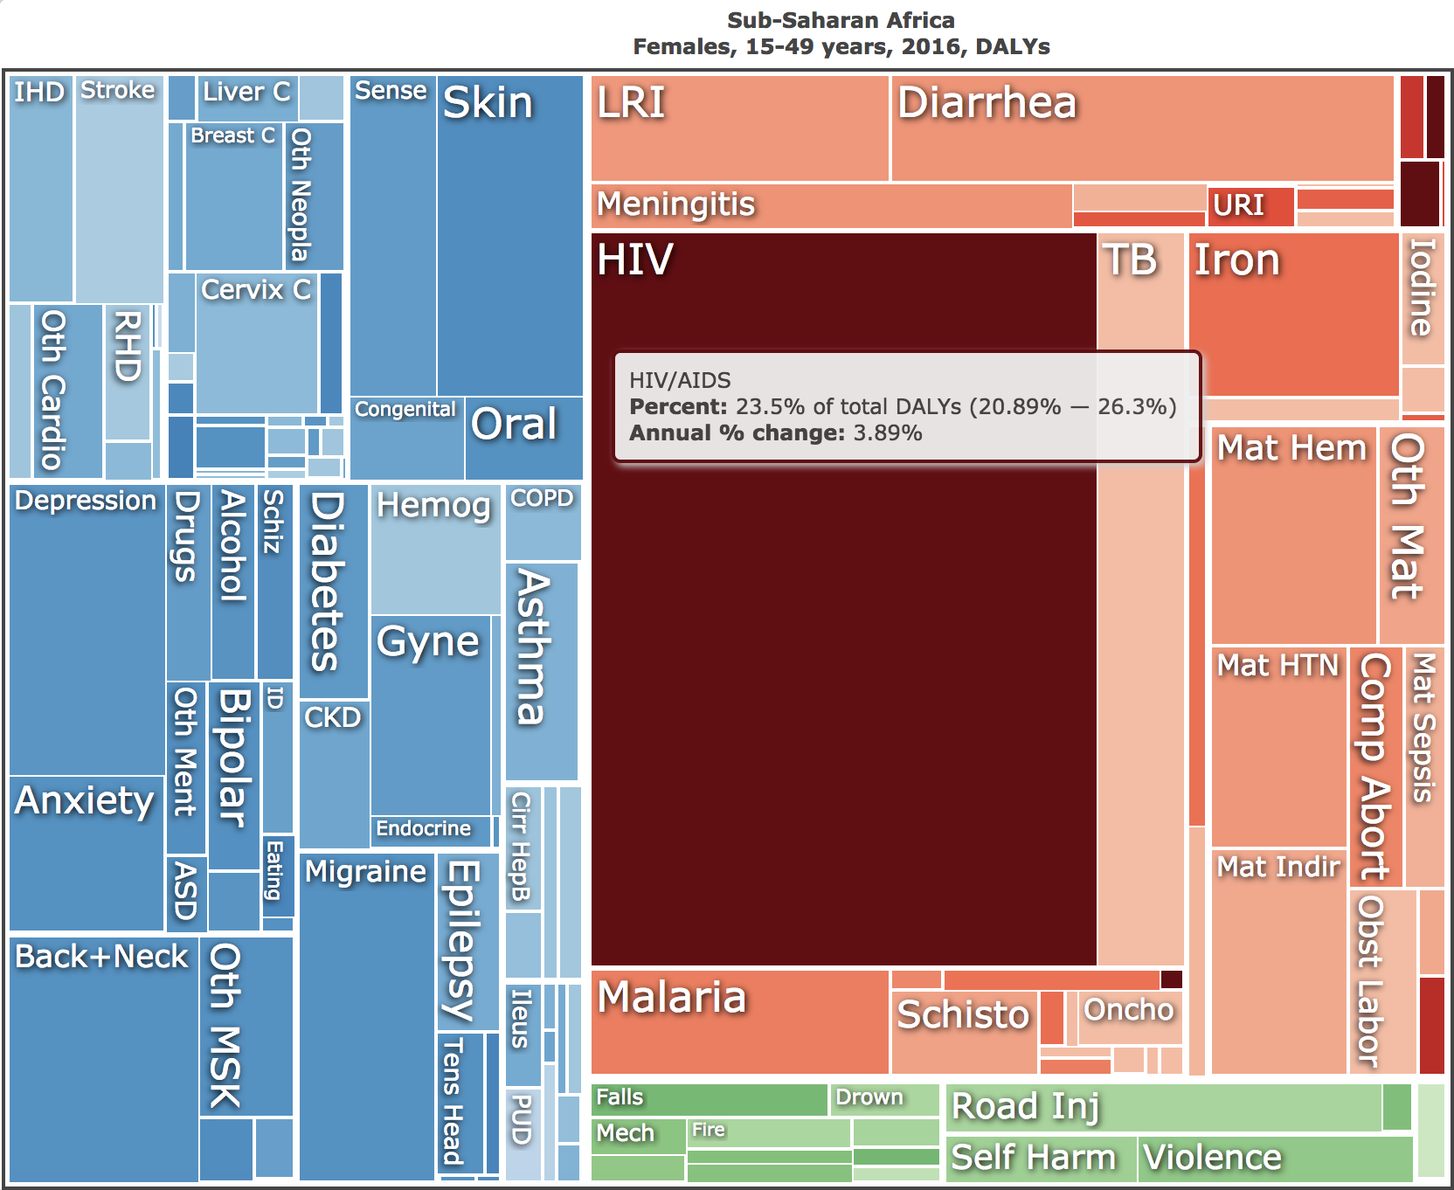

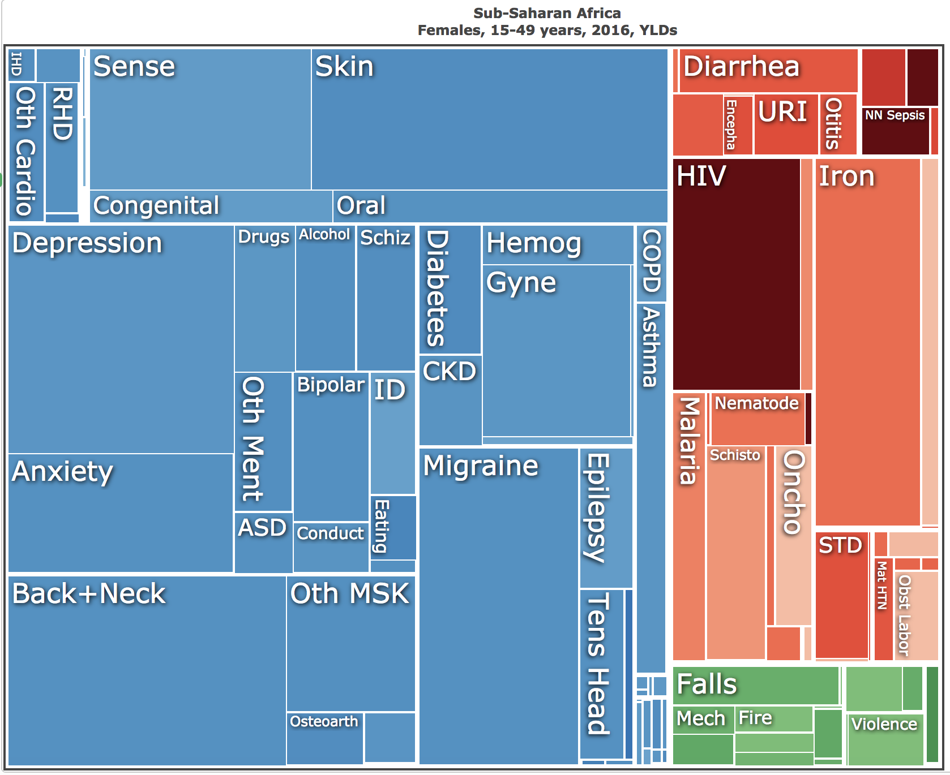

Figure 5. Interactive data visualizations produced by the IHME’s online tools. Source: https://vizhub.healthdata.org/gbd-compare/

The only other organization to provide similarly comprehensive health metrics information is the WHO [14]. However, as a United Nations organization, its work cannot be fully disconnected from the influence of UN member nations [14]. In contrast, the core principle underlying the GBD is impartiality [7]. The IHME’s research is fully separate from efforts to create, advocate for, or implement global health programs, significantly minimizing the potential for conflicts of interest [7].

Apart from the integrity of its data, the IHME offers a secondary benefit for philanthropic groups. Its website contains a wealth of visualization tools that global health practitioners can use to analyze and present information. These tools were used to produce the two images that compose Figure 5. Within minutes, individuals without any statistical background could use the tools to: compare the number of deaths caused by a certain disease across nations; contrast the percentage of males and females with a particular disability; analyze the growth of a disease’s prevalence over a ten-year period; and much, much more [5]. Within Figure 6, one may view an additional example of the visualizations that practitioners could create. The IHME is the sole health metrics organization to make its visualization tools accessible to all.

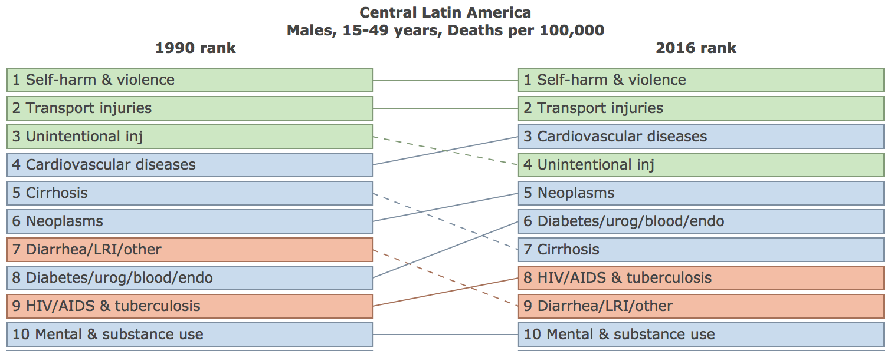

Figure 6. Interactive data visualization produced by the IHME’s online tools. Source: https://vizhub.healthdata.org/gbd-compare/

**Call For Collaborators**

Information from the IHME can help philanthropic groups enhance their impact, secure steady funding, and convince stakeholders of their work’s legitimacy. Therefore, efforts to heighten the policy relevance of IHME research have clear benefits for global health practitioners. It is with this understanding that the IHME invites practitioners to join its collaborator network for the 2017 Global Burden of Disease report.

GBD collaborators review GBD results, data sources, and/or methodological approaches, providing timely feedback related to their areas of expertise [3]. Within this context, global health practitioners can make vital contributions. By leveraging their knowledge of the cultural contexts in which they work, practitioners strengthen the IHME’s understanding of social, cultural, and political forces motivating its results. As the IHME builds its knowledge base, it can better support philanthropic groups seeking to utilize health metrics in their day-to-day work. Individuals and organizations interested in joining the network are encouraged to apply [here](https://catalyst.uw.edu/webq/survey/gbdsec/312337?solstice_selected_button=btn_b70d1910bb96fe5273cf12f11836bef7_1&sol_button_data_btn_b70d1910bb96fe5273cf12f11836bef7_1=0e103cdf0cac4028131940f4c488f1bd0b9719cf0deef31347aa89062e0dcef71cd469e77122be).

At present, there exists great potential for mutually beneficial relationships between philanthropic organizations and health metrics centers. The IHME sincerely hopes to build on and develop this potential to address the 21st century’s most pressing global health issues.

**References List**

1. “About GBD.” *Institute for Health Metrics and Evaluation*. University of Washington,

n.d. Web. 25 Sept. 2017.

2. “An Organization to Support and Strengthen Geospatial Data in Africa.” *Bill & Melinda Gates*

*Foundation*. Bill & Melinda Gates Foundation, n.d. Web. 25 Sept. 2017.

3. “Call for Collaborators.” *Institute for Health Metrics and Evaluation*. University of Washington, n.d. Web. 25 Sept. 2017.

4. “Data and Information.” *Bill & Melinda Gates Foundation: Postsecondary Success*. Bill

Melinda Gates Foundation, n.d. Web. 25 Sept. 2017.

5. “Data Visualizations.” *Institute for Health Metrics and Evaluation*. University of Washington,

n.d. Web. 25 Sept. 2017.

6. “Frequently Asked Questions.” *Institute for Health Metrics and Evaluation*. University of Washington, n.d. Web. 25 Sept. 2017.

7. “IHME Principles.” *Institute for Health Metrics and Evaluation*. University of Washington, n.d. Web. 25 Sept. 2017.

8. Koplan, Jeffrey P et al. “Towards a Common Definition of Global Health.” *The Lancet* 373.9679 (2009): 1993–1995. *ScienceDirect*. Web.

9. Mastro, Dr. Timothy. “Academia Takes on Global Health.” *Huffington Post*. Oath Inc., 14 Apr. 2017. Web.

10. McArthur, John W., and Krista Rasmussen. *Change of Pace: Accelerations and Advances during the Millennium Development Goal Era.* Working paper no. 98. N.p.: Brookings Institution, 2017. Print.

11. "Millennium Development Goals (MDGs)." *WHO.* World Health Organization, n.d. Web. 25 Sept. 2017. <http://www.who.int/topics/millennium_development_goals/about/en/>.

12. Murray, Christopher J.L. “Shifting to Sustainable Development Goals — Implications for Global Health.” *New England Journal of Medicine* 373.15 (2015): 1390–1393. *Taylor and Francis+NEJM*. Web.

13. Murray, Christopher J.L., and Julio Frenk. “Health Metrics and Evaluation: Strengthening the

Science.” *The Lancet* 371.9619 (2008): 1191–1199. *www.thelancet.com*. Web.

14. Smith, Jeremy. “Life, Not Death, Is Focus of New Health Metrics.” *Discover*. Kalmbach

Publishing, 11 Dec. 2013. Web. 25 Sept. 2017.

15. *The U.S. Government Engagement in Global Health: A Primer*. Rep. Kaiser Family Foundation, 27 Jan. 2017. Web. 25 Sept. 2017. <http://www.kff.org/report-section/the-u-s-government-engagement-in-global-health-a-primer-report/>.

16. United Nations. General Assembly*. Transforming Our World: The 2030 Agenda for Sustainable Development.* N.p.: United Nations, 2015. *www.un.org.* United Nations. Web. 25 Sept. 2017. <http://www.un.org/ga/search/view_doc.asp?symbol=A/RES/70/1&Lang=E>.

17. United Nations. MDG Gap Task Force. *Taking Stock of the Global Partnership for Development*. New York: United Nations, 2015. Print.

18. 5 USCA. Sec. 306. 1993. Print.

19. 5 USCA. Sec. 306. 2010. Print