Uma Ramesh
10/17/17
WRIT044.02
Rachel Obbard
Memory Retrieval Benefits Information Transfer

Abstract

At this time, few cognitive scientists have examined which study strategies best help people succeed at tasks that require information transfer. However, this type of problem-solving is especially relevant for both students and the general adult population. Educators who work with students at the high school level and beyond often evaluate them with tests that require sophisticated information transfer skills. Further, most adults use information transfer on a regular basis to solve problems in their day-to-day lives. As such, information transfer research may have implications for pedagogy, student success, and – more broadly – adults’ problem-solving behavior. Our experiment contrasts the impact of two study strategies - restudying and retrieval practice - in facilitating information transfer. We conclude that retrieval practice is significantly more effective.

1. Introduction

The majority of students who enrolled in an American public college in 2011 did not graduate in four years [1, 3]. That same year, approximately 25% of American high school seniors failed to graduate [7]. When students take longer than usual to complete their education, their entrance into the full-time workforce is delayed – harming their earnings potential, as well as the well-being of family members who depend on their income. Logic indicates that, to help American students achieve greater academic success, it is essential to guide them towards strategies for effective studying.
A substantial body of research indicates that retrieval practice is an effective strategy for rote memorizing information [4, 6, 14]. This study technique involves attempting to recall information from memory without receiving any clues as to the right answer [4]. For example, students who memorize vocabulary words by quizzing themselves with flashcards are using retrieval practice. In contrast, restudying involves reviewing information that one has already learned [4]. Students who prefer restudying might prepare for an examination by re-reading relevant textbook chapters. Cognitive scientists have repeatedly proven this technique to be less effective than retrieval practice for rote memorization [4].
While considerable research exists on rote memorization, students at the high school level and beyond are often faced with tests that require more sophisticated problem-solving skills. For example, these students regularly encounter problems with information transfer components [5]. This type of problem-solving consists of applying learned knowledge to novel situations. At present, few researchers have compared the impact of different study strategies on testing performance for problems requiring information transfer. Research on this topic may have implications not only for pedagogy, but also for adult problem-solving behavior in general; most adults, within the course of their day-to-day lives, often find themselves required to apply prior knowledge to new situations. Our experiment aims to contrast the effectiveness of restudying and retrieval in facilitating information transfer.

2. Background

2.1 – Shifting Perspectives on Study Strategies

Until relatively recently, study techniques, such as retrieval practice and restudying, were rarely discussed within pedagogical literature [4]. For example, from 2000 to 2005, the National Research Council published multiple books about student learning – none of which mentioned either restudying or retrieval [9, 10, 11]. For centuries, analysis of study strategies was deemed largely irrelevant, since scientific orthodoxy held that successfully learning information allowed individuals to recall knowledge verbatim [4]. As such, most learning-related studies focused on deep, meaningful encoding of knowledge and experience; from there, it was believed, recall would result naturally [4]. However, evidence makes clear that this view of memory is inaccurate.
A sizeable body of research indicates that human beings cannot recall knowledge and experiences verbatim, regardless of the depth with which their memories were encoded [2, 8, 12, 13]. Instead, when asked to summon information from memory, people only retrieve certain parts of what they learned; the quality of knowledge reconstruction can vary greatly, based on context and retrieval cues within one’s environment [2, 8, 12, 13]. For example, an individual might encode memories of relaxing with a friend as enjoyable. However, imagine that this person later ended their friendship acrimoniously. If, after the split, a retrieval cue brought back these old memories, the person would likely not recall these experiences exactly as they took place [2, 8, 12, 13]. Instead, the context of the individual’s split with their friend would alter reconstruction of these memories – possibly leading the individual to remember more negative aspects of their experience [2, 8, 12, 13]. This paradigm shift in memory research led multiple cognitive scientists to re-consider prior assumptions about the inconsequential nature of study strategies.

2.2 – Overview of Study Strategy Research

From a learning standpoint, this improved understanding of memory created a number of new questions about study strategies [4]. Most centrally, if successful encoding does not guarantee verbatim recall, what techniques help students achieve near this standard on assessments [4]? As noted above, multiple studies have indicated that retrieval practice better facilitates rote memorization than restudying [4, 6, 14]. Certain researchers theorize that the connection between retrieval practice and academic success has an evolutionary basis [4]. If an individual tries to recall information once, that knowledge is likely important [4]. Few people would take the effort of summoning up knowledge from memory without the belief that their effort would yield some sort of reward [4]. As such, the person is likely to try to recall the same information later on; given this logic, it is adaptive for the human brain to better remember information that individuals retrieve [4].
However, evidence also indicates that students gravitate naturally towards restudying when preparing for tests. Within a 2009 survey of 177 college students, over 50% stated that they repeatedly engaged in restudying before assessments; in contrast, only 10.7% of the students engaged in retrieval practice [5]. Given students’ preference for restudying, learning research often involves making comparisons between restudying and retrieval practice [4]. Doing so ensures maximum relevance to students’ day-to-day lives.

3. Methodology

Within this study, subjects were asked to solve both information transfer and rote memorization problems. As noted above, our research is primarily focused on the impact of different study strategies on information transfer. However, the causal link between retrieval practice and success with rote memorization is one of the few substantiated findings within this area of study [4, 6, 14]. As such, we sought to strengthen the existing body of research on study strategies by attempting to replicate the finding.
At the start of each experiment, participants were shown the multi-colored map displayed in Figure 1. Subjects were told that they were looking at a “zombie density map.” The color of each square reflected the number of zombies in the area, with a darker color indicating higher zombie density. Before solving problems, subjects were randomly assigned to engage in restudying or retrieval practice to review information from the map. As such, comparing participants’ performance provides insight into each study method’s impact on learning. All subjects were undergraduate students at Dartmouth College.
The study was comprised of two separate experiments, each drawing a distinct pool of participants. Experiment 1 exclusively tested the comparative impact of retrieval practice and restudying on problems that required rote memorization. Experiment 2 tested the impact of retrieval practice and restudying on both rote memorization and information transfer problems.

Figure 1 – Above is displayed the “zombie density map” used within both experiments.

3.1 - Experiment 1 Overview

Within Experiment 1, all subjects spent one round learning the grid through the procedure demonstrated in Figure 2. Specifically, subjects were shown each square on the map within a separate trial. For each square, subjects would be given six seconds to correctly identify its color and two seconds to look at its position. Once a subject had identified a square’s color correctly, it remained on their representation of the map; in essence, within each trial, subjects would see not only one new square, but all others that they had correctly identified from subsequent trials.

Figure 2 – The images above are screenshots taken during round 1 of the experiment and
reflect the procedure through which subjects learned the colors on the zombie density map.

From there, subjects would be randomly assigned to engage in restudying or retrieval practice. Participants within the restudying group would repeat the above procedure for three rounds. Those within the retrieval practice group studied the map for three rounds as well; within each, subjects were asked to identify the color of each square on the grid from memory. Figure 3 further demonstrates the differences between the restudying and retrieval practice trials.

Figure 3 – The images above are screenshots taken during retrieval and restudying rounds, respectively. These reflect the procedures through which subjects studied the colors on the zombie density map.

Having completed these rounds, participants would leave the laboratory and return after one day. At that point, they would be asked to complete a rote memorization exercise – recreating the map from memory. In essence, all participants would be asked to follow the procedure of the retrieval practice exercise for one round.

3.2 - Experiment 2 Overview

Experiment 2 was, in most aspects of its procedure, quite similar to Experiment 1. However, certain parts of the experimental design were modified, taking into account the reality that information transfer problems are more complex than those requiring rote memorization. The procedure was altered to provide participants with more support as they learned about the map, circumventing the possibility that all results would be poor due to the difficulty of the task. The first round of both Experiments 1 and 2 functioned identically. However, within Experiment 2, participants were provided with a map that contained more shade differentiation; this map is displayed in Figure 4. Further, participants were randomly assigned to do four, rather than three, rounds of restudying or retrieval practice.

Figure 4 – The image above is a visualization of Experiment 2. It represents the map participants were asked to learn, as well as the information transfer task that they performed.

On the second day of the experiment, participants were asked to solve an information transfer problem and then completed the rote memorization task from Experiment 1. The information transfer problem was structured as follows. Each subject was shown 12 sets of 6 grids each; participants learned that each grid represented a “route” through the area depicted on the zombie map. Examples of routes are displayed in Figure 4. Subjects were asked to rank the routes within each set, based on which would minimize zombie contact the most.

4. Results & Discussion

Within both Experiments 1 and 2, subjects who engaged in retrieval practice performed significantly better on the rote memorization task than those who had done restudying. In Experiment 1, participants who engaged in retrieval practice correctly identified the colors of, on average, 51% of squares from the “map” (SD = .21). In contrast, subjects who had been assigned to restudy the grid only identified the colors of 38% of the squares correctly (SD = .22). During Experiment 2’s rote memorization task, participants from the retrieval group correctly identified, on average, the colors of 46% of the squares correctly (SD = .19). In contrast, those who had engaged in restudying only identified the colors of 37% of the squares correctly (SD = .14). Within Experiment 1, t = 2.32 with 61 degrees of freedom, while p = .01. Within Experiment 2, for the rote memorization task, t = 2.25 with 61 degrees of freedom, while p = .014.
Within these experiments, the performance gaps between subjects in the retrieval and restudying groups were statistically significant. Figures 5 and 6 provide further information on subjects’ performance during Experiments 1 and 2, respectively. Within each figure, the “Error” chart reflects how inaccurate subjects’ errors were. When identifying the color of a square, participants had the opportunity to choose between 5 shades; the error measurements reflect, on average, how far participants’ guesses were from the true shade when they made mistakes. If a subject was only one shade off, their error would be reported as a 1; error measurements increase by increments of 1, based on the magnitude of a participant’s mistake.
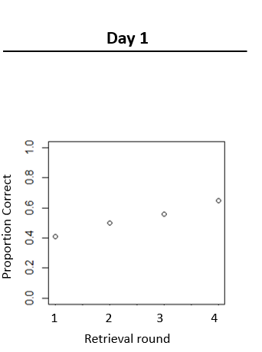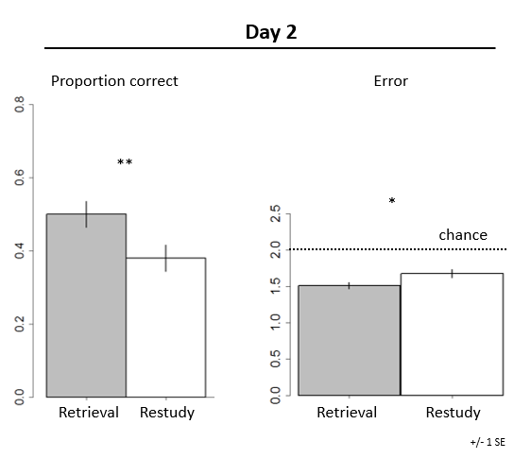
Figure 5 – The images above represent subjects’ performance during Experiment 1.

During Experiment 2, subjects who engaged in retrieval practice performed significantly better on the information transfer task than those who had done restudying. To measure a participant’s performance, we calculated the spearman correlation (Rho) between correct responses and those given by the subject. For participants who had done retrieval practice, the average spearman was .26 (SD = .21). In contrast, for subjects who had restudied, the average spearman was .14 (SD = .26). The performance gap between participants for this task was statistically significant; t = 2.58 with 106 degrees of freedom, while p = .005.
The results of this study confirm that retrieval practice facilitates rote memorization more effectively than restudying. Further, our research suggests that people who study through retrieval practice experience more success with information transfer than those who restudy. However, our research design contains multiple limitations. First, due to logistical constraints, the study population for each experiment was fairly small. Experiment 1 had a sample size of 63 students, while Experiment 2 had a sample size of 108. Further, as noted previously, all subjects were undergraduate students from Dartmouth College. As such, it remains unclear to what extent their performance was impacted by their age, socioeconomic status, and academic ability. Given this, we remain unable to extrapolate these results to a more diverse population.

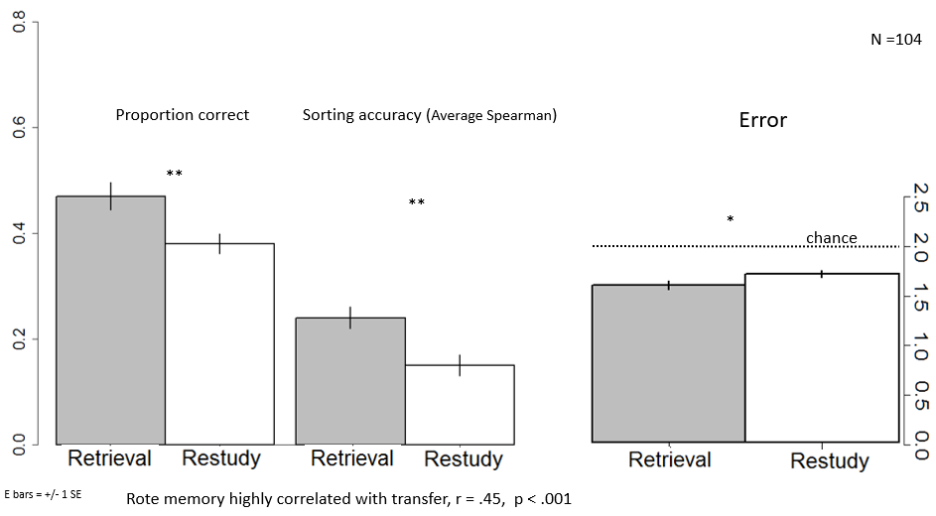
Figure 6 – The image above represents subjects’ performance during Experiment 2.

5. Conclusion

Within this study, we aimed to compare the impact of restudying and retrieval practice on individuals’ performance for problems requiring information transfer. In the process, we also sought to examine the finding, yielded by multiple other studies, that retrieval practice facilitates rote memorization more effectively than restudying [4, 6, 14]. Our research, which focused on Dartmouth undergraduate students, indicates that retrieval practice is more effective than restudying in helping students succeed at information transfer. Further, this study confirms that retrieval practice is more impactful than restudying in allowing students to master rote memorization. At present, we lack sufficient evidence to extrapolate these findings to more diverse populations. However, this research suggests that retrieval practice might be an even more potent strategy for problem-solving success than was previously believed.
Should further studies confirm our findings about information transfer, teachers and tutors would be well served to encourage students to make retrieval practice their primary study strategy. However, even without further research, educators possess considerable evidence of retrieval practice’s positive impact on rote memorization skills. As such, they would almost certainly see student improvement result from a greater embrace of this study strategy.

6. Acknowledgements

I extend my sincerest thanks to Professor Sean H. Kang, of Dartmouth College, for designing and supervising the implementation of this study. I am profoundly grateful as well to the Women in Science Project for funding my involvement in this research. Finally, I thank Luke G. Eglington, a graduate student in Dr. Kang’s Cognition and Education Lab, for helping me access experiment data.
References

- “About this project.” College Completion, The Chronicle of Higher Education, collegecompletion.chronicle.com/state/.
- Bartlett, F. C. (1932). Remembering: A study in experimental and social psychology. Cambridge, England: Cambridge University Press.
- “Graduation Rates.” College Completion, The Chronicle of Higher Education, collegecompletion.chronicle.com/state/.
- Karpicke, J. D. (2012). Retrieval-Based Learning: Active Retrieval Promotes Meaningful Learning. Current Directions in Psychological Science, 21(3), 157–163. https://doi.org/10.1177/0963721412443552
- Karpicke, J. D., et al. (2009). Metacognitive Strategies in Student Learning: Do Students Practise Retrieval When They Study on Their Own? Memory, 17(4), 471-479. doi:10.1080/09658210802647009.
- Karpicke, J. D., & Roediger, H. L. (2007). Repeated retrieval during learning is the key to long-term retention. Journal of Memory and Language, 57(2), 151–162. https://doi.org/10.1016/j.jml.2006.09.004
- Miller, Tony. “Partnering for Education Reform.” U.S. Department of Education. Church of God in Christ's International AIM Convention, 7 July 2011, Houston, Texas, www.ed.gov/news/speeches/partnering-education-reform.
- Moscovitch, M. (2007). Memory: Why the engram is elusive. In H. L. Roediger, Y. Dudai, & S. M. Fitzpatrick (Eds.), Science of memory: Concepts (pp. 17–21). New York, NY: Oxford University Press.
- National Research Council. (2000). How people learn: Brain, mind, experience, and school. J. D. Bransford, A. L. Brown, & R. R. Cocking (Eds.). Washington, DC: National Academies Press.
- National Research Council. (2005a). How students learn: Science in the classroom. M. S. Donovan & J. D. Bransford (Eds.). Washington, DC: National Academies Press.
- National Research Council. (2005b). Taking science to school: Learning and teaching science in grades K-8. R. A. Duschl, H. A. Schweingruber, & A. W. Shouse (Eds.). Washington, DC: National Academies Press.
- Neisser, U. (1967). Cognitive psychology. New York, NY: Appleton-Century-Crofts.
- Roediger, H. L. (2000). Why retrieval is the key process in understanding human memory. In E. Tulving (Ed.), Memory, consciousness, and the brain: The Tallinn conference (pp. 52–75). Philadelphia, PA: Psychology Press.
- Roediger, H. L., & Butler, A. C. (2011). The critical role of retrieval practice in long-term retention. Trends in Cognitive Sciences, 15(1), 20–27. https://doi.org/10.1016/j.tics.2010.09.003

