Jayson Chojar

It’s not theft. It’s copyright infringement.
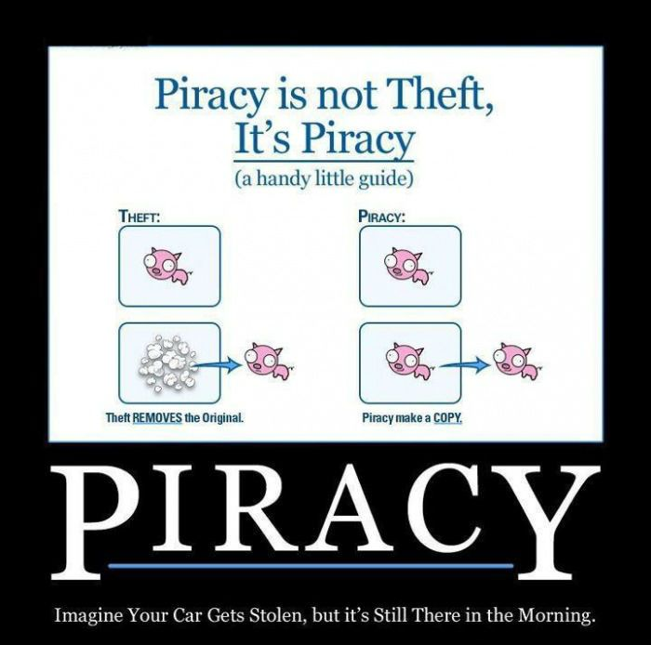

WeKnowMemes, 2012

“Imagine your car gets stolen, but it’s still there in the morning.” Seems simple enough as an analogy, right? I asked five people to respond to this. All five were confused. All five couldn’t figure out whether or not to agree. Not one of the five had ever considered a distinction between piracy and theft.
I decided I was going to try to #DefineTheDistinction. I also wanted to evaluate my definition, and the best way I knew how was to see how others responded when presented with it. Now, I wanted to give everyone I spoke to the best visualization I could of the stolen car analogy, as it confused the first few people I offered it to. So I set out to recreate the analogy in real life as part of my presentation. The trouble was, I didn’t know how to duplicate a car—if I could, I’d be super rich by now. With some editing help from a friend and a legally borrowed car from another, I stitched together a clip of a car pulling away with a still image of the parked car. The result looks like I pulled a car out of itself to create a copy, which fits very nicely with the analogy described in the image above. Which brings me to the first part of my video. I asked each person I interviewed to respond to my claim regarding piracy, framed around this stolen car analogy, now visualized.
The claim? Piracy is not analogous to theft, as it has no explicit costs. Copyright holders suffer no accounting loss by function of piracy, and, void of a tangible loss, cannot be victims of theft. Theft is defined as “the action or crime of stealing” (New Oxford American Dictionary), and while copyright holders may incur an economic loss—which is to say, an implicit loss of opportunity to gain—nothing has been stolen in a technical sense. Piracy is copyright infringement, an “unauthorized use or reproduction of [a copyrighted] work” (New Oxford American Dictionary). But how can piracy be stealing if it doesn’t take the original away from its owner? A pirate doesn’t reproduce the supposed cost of a copyrighted material; he reproduces the material itself. The original is left intact—unaltered and undamaged.
After asking interviewees to accept or reject my claim, I asked them to elaborate on their positions. I asked whether they are for or against piracy, whether our conversation has influenced their viewpoints, and, most importantly, whether they would like to propose an alternative definition of piracy. With all my interviews, I was hoping for a profound answer to this question. I hoped for examples that would not only highlight my definition of piracy but also subject it to others and their suppositions, offering a test of the quality of my definition. Not only that, but I also had a stream of suggestions and revisions that I was crowdsourcing.
Videotaping my interviews was the clear choice for me, not just from a writing standpoint, but from a communications standpoint as well. My objective wasn’t just to convey my definition of piracy to the people I spoke with, it was to test my definition of piracy, and ultimately, to combine my thoughts and ideas with everyone else’s into one comprehensive evaluation of piracy. By recording my interactions and conversations with people, I could refer back to them later when looking for key points to address in my letter. Similarly, when it came time to present my text, a video was an especially effective means of communicating my message and showcasing my findings throughout the process. Specifically, while the image atop this letter offers a basic visualization, watching a physical car drive away and then watching a physical car appear to materialize out of itself and drive away was much more evocative as a visualization; a picture is a picture, but people react very differently to watching something they would expect to be impossible. But nonetheless, the real question is: did my theatrics and my attempts to explain my definition of the distinction between piracy and theft lend credence to my work, or would I be the one learning from the insight of my interviewees?

