Jayson Chojar

It’s not theft. It’s copyright infringement.
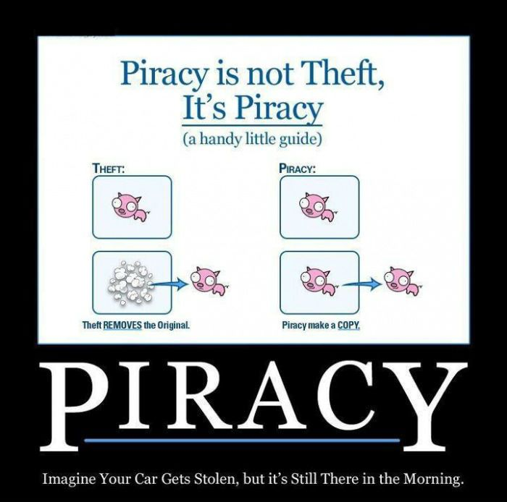

WeKnowMemes, 2012

“Imagine your car gets stolen, but it’s still there in the morning.” Seems simple enough as an analogy, right? I asked five people to tell me what they thought of the analogy (pictured above). All five were confused. All five couldn’t figure out whether or not to agree. Not one of the five had ever considered a distinction between piracy and theft.
I decided to try to #DefineTheDistinction. From an economic standpoint, I contended piracy was not analogous to theft; specifically, I argued theft involves some tangible loss and that I could identify no such loss in cases of piracy. Copyright holders may incur an implicit “opportunity cost,” as they are unlikely to receive payment in a case of pirated content; however, piracy does not prohibit them from selling further units of digital content. Thus, if piracy leaves copyright holders void of a tangible loss, they cannot be victims of theft.
Piracy is copyright infringement, an “unauthorized use or reproduction of [a copyrighted] work” (New Oxford American Dictionary). Conversely, theft is defined as “the action or crime of stealing” (New Oxford American Dictionary), and while copyright holders may incur an implicit loss (of opportunity to gain), nothing has been “stolen” in a technical sense. So how can piracy be stealing if it doesn’t take the original away from its owner? A digital pirate doesn’t reproduce the estimated cost of a copyrighted material; he reproduces the material itself. The original is left intact—unaltered and undamaged. For this reason, I claimed piracy lay outside of the umbrella of theft, and I defined piracy merely as reproduction rather than removal, akin to counterfeiting rather than stealing.
Which brings me to the introductory segment of my video. Firstly, I defined piracy and theft to offer some exposition on my claim that they differed. The image atop this letter regarding piracy and theft followed, along with a voiceover elaborating on the distinction between the two illicit activities. The “stolen car” analogy captioned below the image confused the first few people I offered it to, so I set out to create a real-life visual representation of the image as part of my presentation in order to give everyone I spoke to the best visual aid I could. The trouble was, I didn’t know how to duplicate a car—if I could, I’d be super rich by now. With some editing help from a friend and a legally borrowed car—can’t stress that enough—from another, I stitched together a clip of a car pulling away with a still image of the parked car. The result looks like I pulled a car out of itself to create a copy, which fits very nicely with the analogy described in the image above, and offers a more visceral look into my claim. Specifically, while the image atop this letter offers a basic visualization of the hypothesized “stolen car” analogy, watching a physical car appear to materialize out of itself and drive away was much more evocative as a visualization; a picture is a picture, but people react very differently to watching something they would expect to be impossible.
Next, I wanted to evaluate my definition of piracy, which I did the best way I knew how: present my claim to others and analyze their responses. Interacting with other people and their viewpoints allowed me to make connections between a broad range of opinions and evidence, and the diverse body of ideas proposed in our conversations proved instrumental in supporting my final summarization of piracy.
Likewise, the video continues with a series of interviews providing responses to my introductory claims and argument. Videotaping my interviews was the clear choice for me, not just from a writing standpoint, but from a communications standpoint as well. My objective wasn’t just to convey my definition of piracy to the people I spoke with, it was to test my definition of piracy, and ultimately, to combine my thoughts and ideas with everyone else’s into one comprehensive evaluation of piracy. By recording my interactions and conversations with people, I could refer back to them later when looking for evidence and key points to address in my letter. Similarly, when it came time to present my text, a video was an especially effective means of communicating my message and showcasing my findings throughout the process.
I asked interviewees to consider and respond to my claim, either accepting or rejecting my initial assessment of the distinction between piracy and theft. With all my interviews, I was hoping for profound analyses, and I hoped for examples that would not only highlight my definition of piracy but also subject it to others’ and their suppositions, offering a test of my definition’s quality. Not only that, but regardless, I also had a stream of suggestions and revisions that I was crowdsourcing. In most cases, as they elaborated on their positions, they addressed whether they were for or against piracy and whether our conversation had impacted or influenced their viewpoints.
Most importantly, however, were the cases in which they proposed alternative definitions of piracy and/or added new considerations into the mix. For instance, one friend of mine mentioned the loss of “sole ownership,” which I had not considered. I proposed that copyright holders don’t lose anything concretely, in the sense that they cannot have it back. I meant it in the context of tangible loss, in the context of always having the original file. But piracy functionally removes sole ownership, and while sole ownership is not tangible, it concretely vanishes after the first instance of piracy. Additionally, some participants labeled piracy as theft irrespective of a lack of “tangible loss.” They felt a more practical definition of theft and piracy was necessary and that the theoretical implicature of a “tangible” loss was irrelevant in context. From a pragmatic standpoint, piracy and theft have many similar/identical impacts when considered holistically, and as I reflected on my initial consideration of the distinction, I realized that I had been overly technical, focused on the semantics of the definitions rather than on their substance.
Armed with greater insight, context, and knowledge, I concluded my video with a revised summarization of piracy and its relation to theft. Piracy may be more accurately defined as a specialized form of theft, characterized by the illegal procurement or use of [copyrighted] content. The video in its entirety truly encapsulates the entire, start-to-finish process I underwent. In multiple regards, I had to improvise and adapt in order to tackle some of the challenges I ran into. I had faith that I could create a visualization of the “stolen car” analogy, but no real evidence to support my ability. I had no idea how my initial definitions would be received, and I couldn’t know how to proceed until after I had concluded interviews and my analysis. Nonetheless, I absorbed as much as I could through each step of the synthesis and revision processes and learned a great deal more than I could have alone by working alongside others. Consequently, my final product represents the culmination of all my intuition, examination, and reflection with respect to piracy and its relationship with theft.

